## **Pumpkin Cupcakes**

Recipe from ‘Sally’s Baking Addiction’

*Get ready to celebrate this fall season with the tastiest pumpkin spiced cupcakes. These super moist cupcakes are easy to make, perfectly pumpkin-spiced, and finished with tangy cream cheese frosting.*

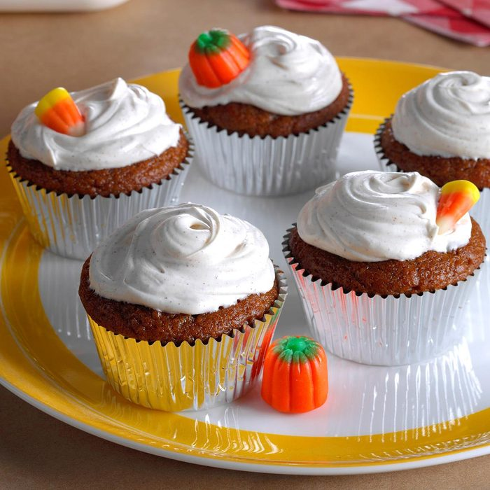

## 

### **Ingredients**

### 1 cup (125g) all-purpose flour (spoon & leveled)

* + 1 teaspoon baking powder
  + 1/2 teaspoon baking soda
  + 1/2 teaspoon salt
  + 1 teaspoon ground cinnamon
  + 1 and 1/2 teaspoons pumpkin pie spice
  + 1/2 cup (120ml) canola or vegetable oil
  + 2 large eggs
  + 3/4 cup (150g) packed light or dark brown sugar
  + 1 cup (225g) canned pumpkin puree
  + 1 teaspoon pure vanilla extract

#### **Cream Cheese Frosting**

* + 8 ounces (224g) full-fat block cream cheese, softened to room temperature
  + 1/2 cup (115g) unsalted butter, softened to [room temperature](https://sallysbakingaddiction.com/room-temperature-butter/)
  + 3 cups (360g) confectioners’ sugar, plus an extra 1/4 cup if needed
  + 1 teaspoon pure vanilla extract
  + 1/8 teaspoon salt

### **Instructions**

1. Preheat the oven to 350°F (177°C). Line a 12-cup muffin pan with cupcake liners.
2. Whisk the flour, baking powder, baking soda, salt, cinnamon, and pumpkin pie spice together in a large bowl. Set aside. Whisk the oil, eggs, brown sugar, pumpkin, and vanilla extract together until combined. Pour the wet ingredients into the dry ingredients and use a mixer or whisk until completely combined. Batter will be thick.
3. Pour/spoon the batter into the liners – fill only 2/3 full to avoid spilling over the sides. Bake for 20-22 minutes, or until a toothpick inserted in the center comes out clean. Allow the cupcakes to cool completely before frosting.
4. **Make the frosting:** In a large bowl using a handheld or stand mixer fitted with a paddle or whisk attachment beat the cream cheese and butter together on high speed until smooth and creamy. Add 3 confectioners’ sugar, vanilla, and salt. Beat on low speed for 30 seconds, then switch to high speed and beat for 2 minutes. If you want the frosting a little thicker, add the extra 1/4 cup of confectioners sugar
5. Frost cooled cupcakes however you’d like.

## **Cheese Tortellini w/ Walnut Pesto**

Recipe courtesy of ‘Food and Wine’

## *With a quick and easy pesto recipe like this one, you’ll be able to enjoy the cheese tortellini in no time. With bright, bold flavors and a smooth, creamy texture, this pasta is perfect for either lunch or dinner.*

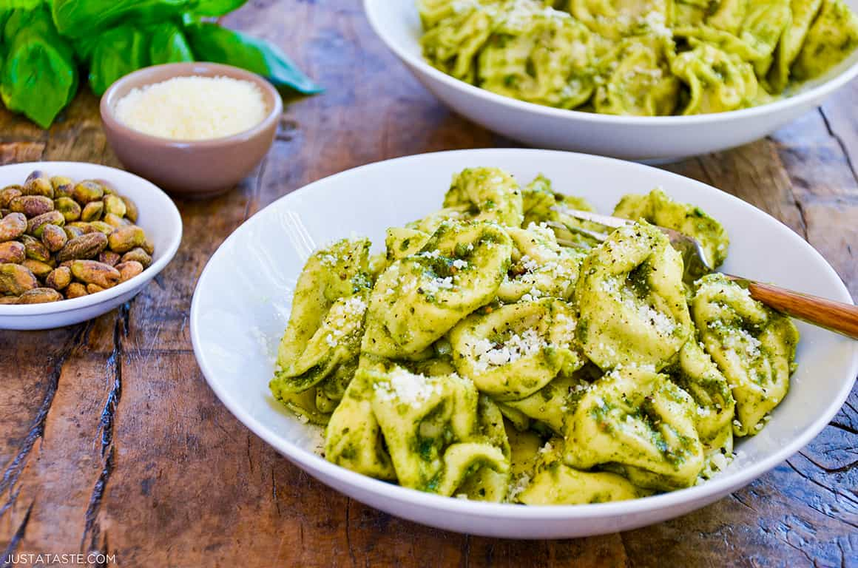

**Ingredients**

* 1 cup walnuts
* ⅓ cup lightly packed flat-leaf parsley with thick stems removed
* 2 cloves garlic (smashed)
* 3 tablespoons grated Parmesan cheese (plus more for serving)
* ½ cup olive oil
* ½ teaspoon salt
* ¼ teaspoon fresh-ground black pepper
* 1 pound fresh or frozen cheese tortellini
* 1 tablespoon butter

**Directions**

1. In a food processor or blender, pulse the walnuts, parsley, garlic, Parmesan, oil, salt, and pepper to a coarse puree.
2. In a large pot of boiling, salted water, cook the tortellini until just done, about 4 minutes for fresh and 12 minutes for frozen. Reserve 1/2 cup of the pasta water. Drain the tortellini. Toss with 1/4 cup of the reserved pasta water, the walnut pesto, and the butter. If the pasta seems dry, add more of the reserved pasta water.
3. Sprinkle with additional Parmesan and pass more at the table.